Teen Dharma Retreat

Age: 13~16
July 24 – 26, 2017 (2 PM, Monday until 4 PM, Wednesday)
Participation fee $ 150
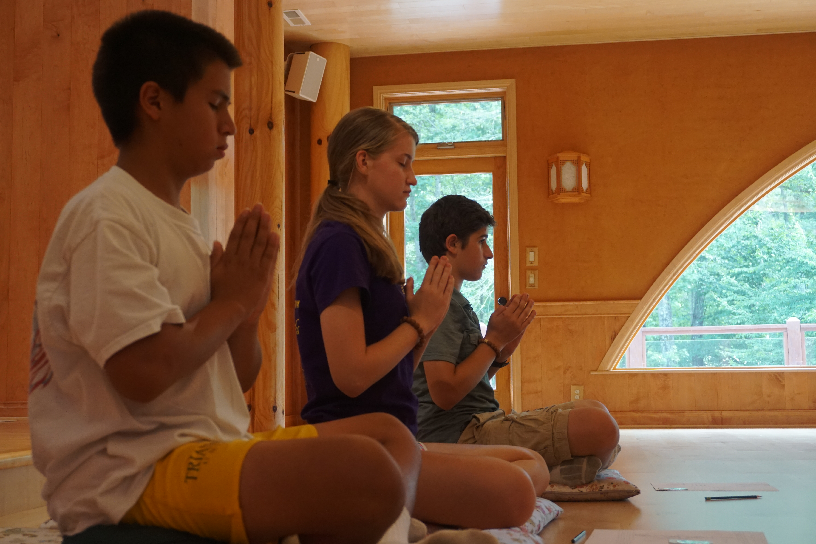

Mindful Meditation:
Sitting, walking, chanting and lying down meditation, tai-chi, yoga,
green tea ceremony

Dharma Activities:
Dharma discussion, journal writing, mandala arts, Cooking class, drumming,
arts & crafts

This camp will be full of fun, insights, creativity, and fellowship as experienced in the many different activities each day. Guided mindfulness and meditation will help participants experience self-discovery, awareness, and self-confidence.
If you are interested in sending your teenager (sons & daughters, grandchildren) to this retreat, please fill out the application and submit it with your payment. If you are interested in applying for a scholarship, please contact us directly (919-933-6946).

Won-Buddhism Meditation Temple
8021 Old NC 86
Chapel Hill, NC, 27516
WonbuddhismNC.org
2017 Teen Dharma Retreat

July 24 – 26 (2 PM, Monday until 4 PM, Wednesday)

Teen's Name
Birthday | Age __________ Gender __________
Hobbies & Interests
Allergies or
dietary restrictions

Parent(s) Name
Phone
Address
Email
Emergency Contact Name & Phone number
What are your expectations
for this retreat?

Consent for Emergency Medical Care
I, __________________________, hereby permit the retreat staff to seek emergency medical assistance for my child (children) and provide basic medical care, in such cases as deemed necessary by the staff.

__________________________________________________________________________________
Parent Signature Date

Consent for Photography and Video
Thank you for joining the teen overnight mindfulness retreat at the Won-Buddhism Meditation Temple. With your permission, we would like to photograph or video retreat activities that may include your child. These materials will be used for reflection and presentation at the last day of the retreat and may be used in our temple website to promote future youth programs. Thank you for your support.

__________________________________________________________________________________
Parent Signature Date

If you are not on our mailing list, would you like to receive e-mails to be updated on Temple programs and the teen retreat? Yes_______ / No_______

